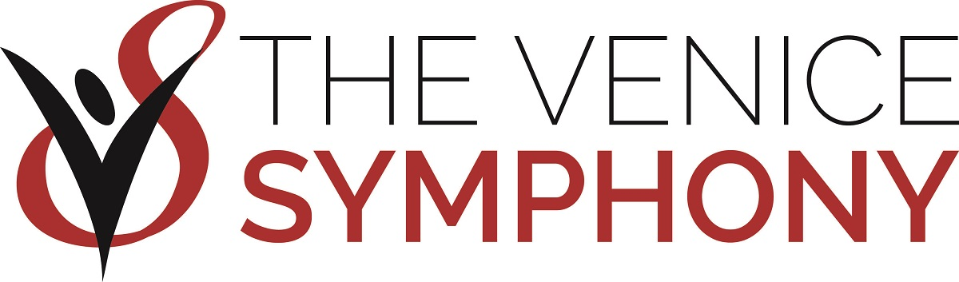
2021-22 ONLINE Season Subscription Order Form

NAME ______________________________________________ EMAIL ____________________________________________

ADDRESS __________________________________________ CITY ________________________ STATE ________ ZIP _______

TELEPHONE ______________________________________ MONTHS IN FLORDIA ____________________________________

FULL-SEASON SUBSCRIBERS must purchase all seven programs. We will do our best but cannot guarantee your seating request. For best available seating, return your order form by August 16, 2021. For more information, call us at 941-207-8822.

Program | Date | # of tickets  $56 $52 $48 $40 $ 35 $31 |  |  |  |  |  | $ Amount
Brahms & The Boys | Fri, Nov 19 @ 7:30pm
 | Sat, Nov 20 @ 3:30pm
A Holly Jolly Holiday | Fri, Dec 17 @ 7:30pm
 | Sat, Dec 18 @ 3:30pm
 | Sat, Dec 18 @ 7:30pm
Under the Big Top:  A Tribute to the Circus | Fri, Jan 14 @ 7:30pm
 | Sat, Jan 15 @ 3:30pm
 | Sat, Jan 15 @ 7:30pm
A Night at the Oscars | Fri, Feb 4 @ 7:30pm
 | Sat, Feb 5 @ 3:30pm
 | Sat, Feb 5 @ 7:30pm
Superheroes & Schumann | Fri, Feb 25 @ 7:30pm
 | Sat, Feb 26 @ 3:30pm
Game of Romes | Fri, Mar 18 @ 7:30pm
 | Sat, Mar 19 @ 3:30pm
Fantasy, Firebird & Fabiola | Fri, Apr 22 @ 7:30pm
 | Sat, Apr 23 @ 3:30pm
Ticket Amount |  |  |  |  |  |  |  | $
Discount | 10% off (7 concerts) |  |  |  |  |  |  | -
 | 5% off (4-6 concerts) |  |  |  |  |  |  | -
Additional Tickets (not part of a package, NO discounts apply) |  |  |  |  |  |  |  | +
SUBTOTAL |  |  |  |  |  |  |  | $
Chair Society | $250 Individual |  |  |  |  |  |  | +
 | $400 Household |  |  |  |  |  |  | +
Friends Membership | $35 Individual |  |  |  |  |  |  | +
 | $45 Household |  |  |  |  |  |  | +
Thank you for your Annual Contribution |  |  |  |  |  |  |  | +
Mailing Fee - $5.00 (OPTIONAL) Otherwise your tickets will be available for pick up |  |  |  |  |  |  |  | +
TOTAL |  |  |  |  |  |  |  | $

REFUND / EXCHANGE POLICY: Refunds available if concert is cancelled or postponed. Free ticket exchanges are offered for Season Subscribers. There are NO exchanges during concert weekend.

SELECT YOUR METHOD OF PAYMENT: MAIL TO: P.O. Box 1561, Venice, FL 34284
A check made payable to The Venice Symphony is enclosed, check # ______________
Please charge my credit card (circle one): VISA MasterCard Discover AMEX
Credit card # ____________________________________________________________________ Expiration Date _____________________
Cardholder’s Signature ____________________________________________________________ Security Code_______________________
If you pay by check please note that if there is a discrepancy between your ticket selection and what was assigned, differences of $10 or less will be considered a donation to the symphony. If payment is made by credit card, the exact amount will be charged to your card. Credit card payments will be processed when seats are assigned in September.

